WEEK – 2
TASK 2.1: BUILD ARRAY FROM PERMUTATION
PROGRAM:
import java.util.*;
import java.util.function.*;

class Solution {
public int[] buildArray(int[] nums) {
return IntStream.range(0, nums.length)
.map(i -> nums[nums[i]])
.toArray();
}
}
OUTPUT:
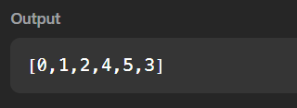

TASK 2.2:SHUFFLE THE ARRAY
PROGRAM:
import java.util.*;
import java.util.stream.*;

class Solution {
public int[] shuffle(int[] nums, int n) {
return IntStream.range(0,n)
.flatMap(i-> IntStream.of(nums[i], nums[i+n]))
.toArray();

}
}
OUTPUT:
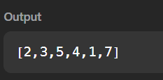

TASK 2.3 : FINDING THE HIGHEST ALTITUDE
PROGRAM:
class Solution {
public int largestAltitude(int[] gain) {
int current = 0;
int highest = 0;
for (int i =0; i < gain.length; i++) {
current = current + gain[i];
if (current > highest) {
highest = current;
}
}
return highest;
}
}
OUTPUT:
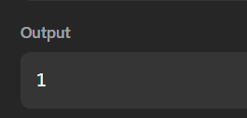

TASK 2.4: JAVA DEQUEUE
PROGRAM:
import java.io.*;
import java.util.*;
public class Solution {
public static void main(String[] args) {
Scanner sc = new Scanner(System.in);
int n = sc.nextInt();
int m = sc.nextInt();
Deque<Integer> deque = new ArrayDeque<>();
HashSet<Integer> set = new HashSet<>();
int maxUnique = 0;
for (int i = 0; i < n; i++) {
int value = sc.nextInt();
deque.addLast(value);
set.add(value);
if (deque.size() == m) {
maxUnique = Math.max(maxUnique, set.size());
int first = deque.removeFirst();
if (!deque.contains(first)) {
set.remove(first);
}
}
}
System.out.println(maxUnique);
sc.close();
}
}

OUTPUT:
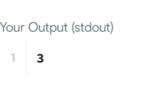

TASK 2.5:JAVA HASHSET
PROGRAM:
import java.util.*;
public class Solution {
public static void main(String[] args) {
Scanner sc = new Scanner(System.in);
int n = sc.nextInt();
HashSet<String> set = new HashSet<>();
for (int i = 0; i < n; i++) {
String first = sc.next();
String second = sc.next();
String pair = first + " " + second;
set.add(pair);
System.out.println(set.size());
}
sc.close();
}
}
OUTPUT:
